**EXPERIMENT NO. 11**

# IMPLEMENTATION OF SUBNETTING USING CISCO PACKET TRACER **EXPERIMENT NO. 11**

**AIM: -** To implementing subnetting using Cisco Packet Tracer.

**OBJECTIVES:**

1. To design IP addressing scheme.
2. To assign IP addresses to network devices and verify connectivity.

**SOFTWARE:** Cisco Packet Tracer.

**SCENARIO:**

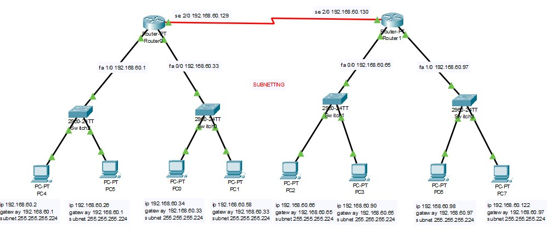

CONFIGURATION OF **FASTETHERNET 0/0, FASTETHERNET 1/0, SERIAL 2/0** INTERFACEs OF **Router0**

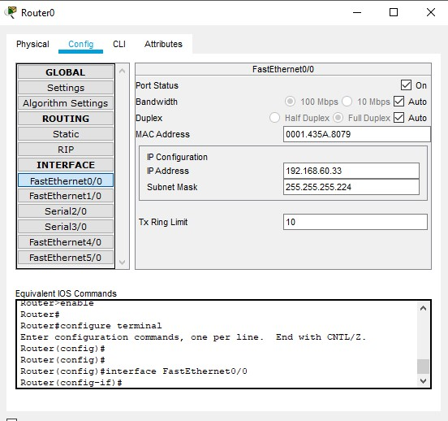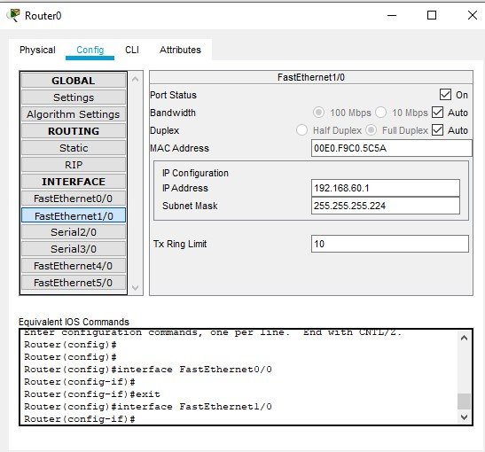

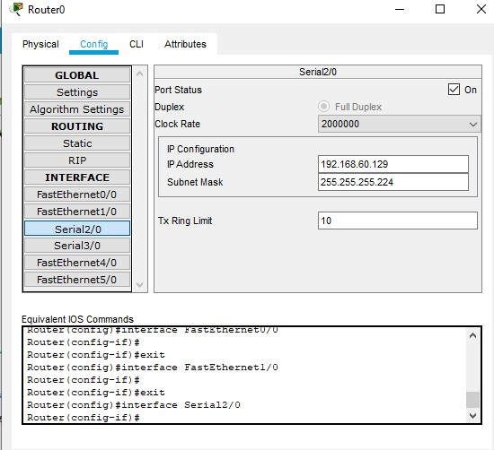

CONFIGURATION OF **FASTETHERNET 0/0, FASTETHERNET 1/0, SERIAL 2/0** INTERFACEs OF **Router1**

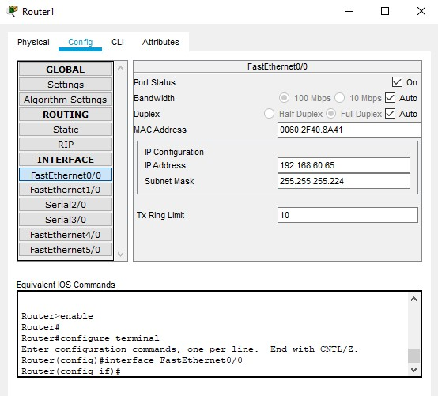

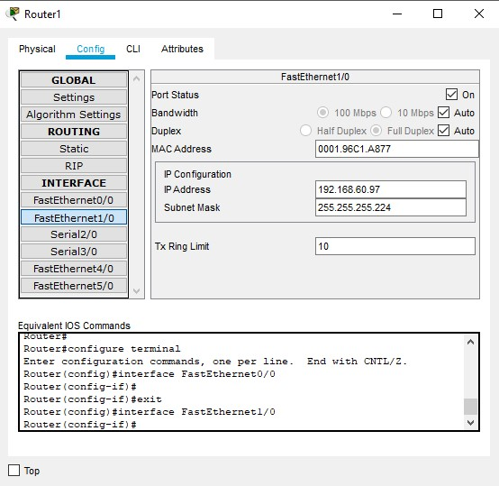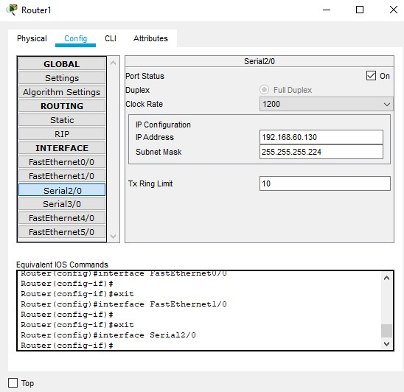

**STATIC ROUTE Router0**

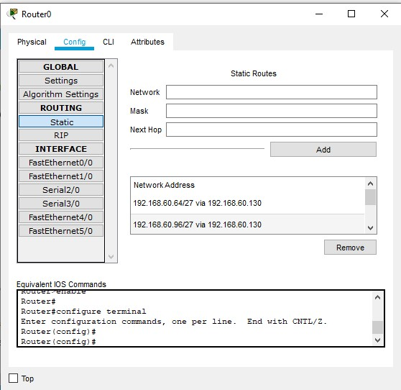

**STATIC ROUTE Router1**

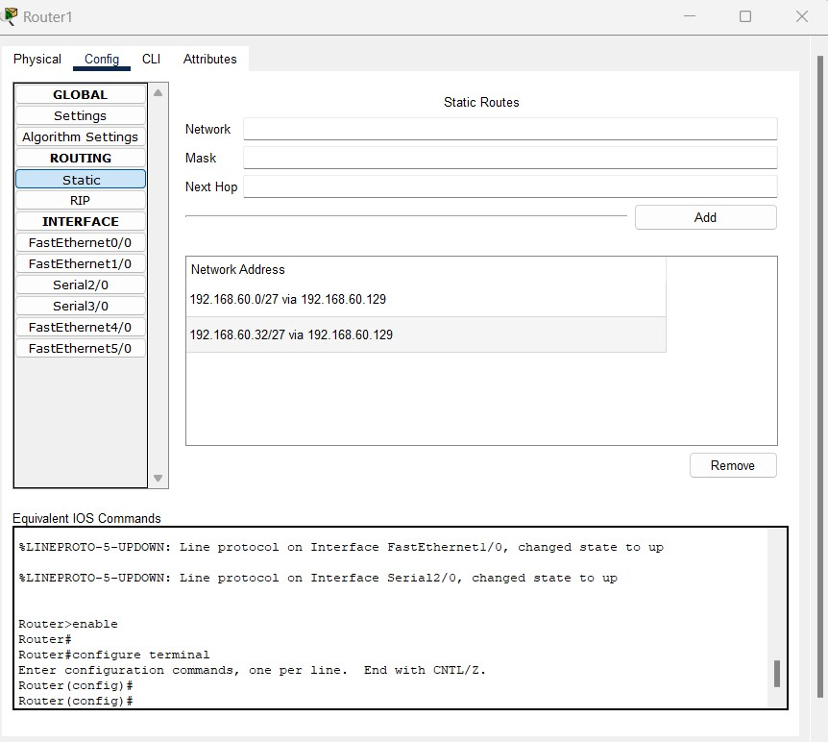

**PING RESPONSE:**

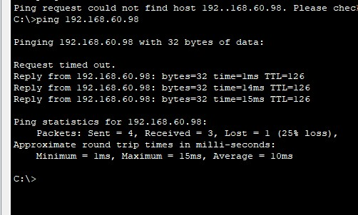

**CONCLUSION:**

Implemention of subnetting using Cisco Packet Tracer was performed successful. Ip address were assigned to each network and the connectivity was verified using ping command in command prompt.